capital start wireframe specs

This document describes wireframes for the Capital Start newsletter. There are 4 wireframes included.

1. Email template
2. Volume 1 landing page
3. Volume 1 main program page
4. Volume 1 main program page with popovers opened

The wireframes have callouts to describe the action of each element. At the end of the document are images of each page without the notation.

# Email

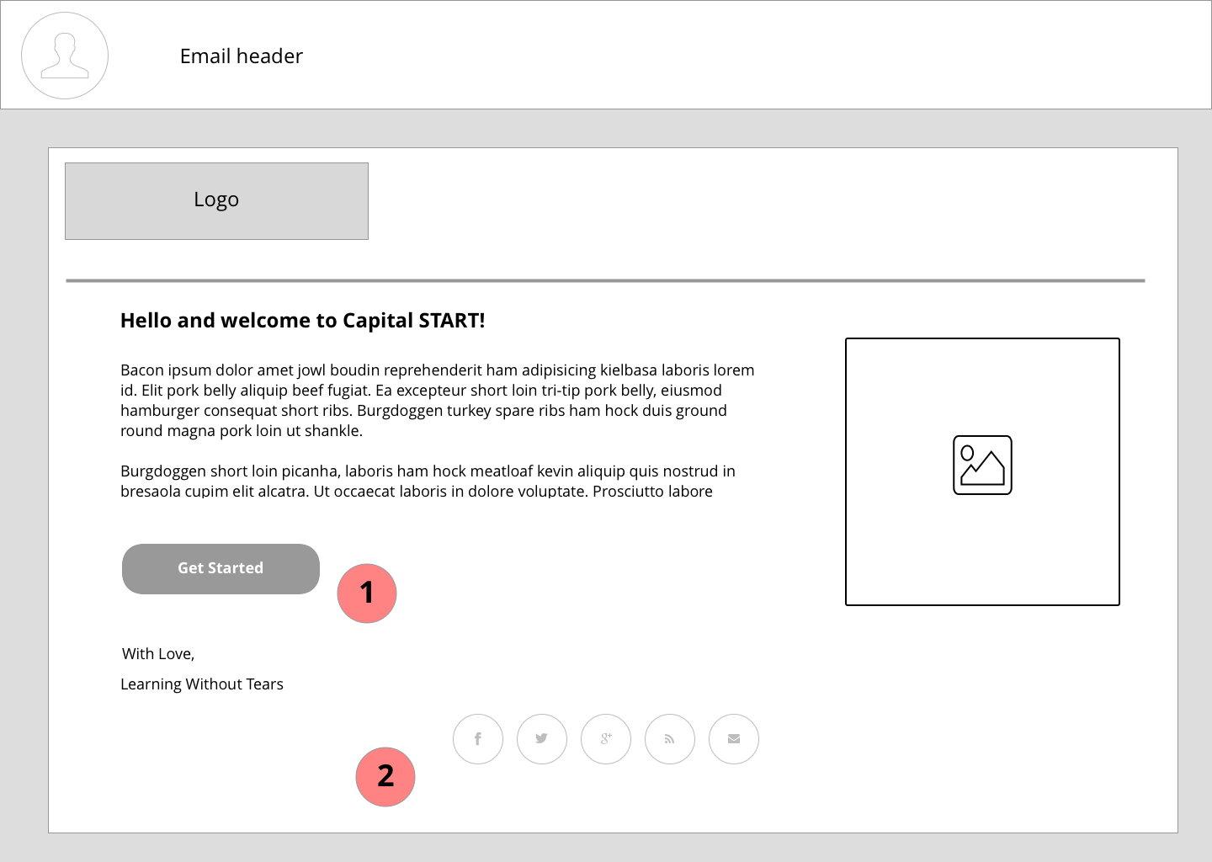

1. Links user to Volume 1 Landing page
2. Links user to LWTears social media

# volume 1 capital start Landing page

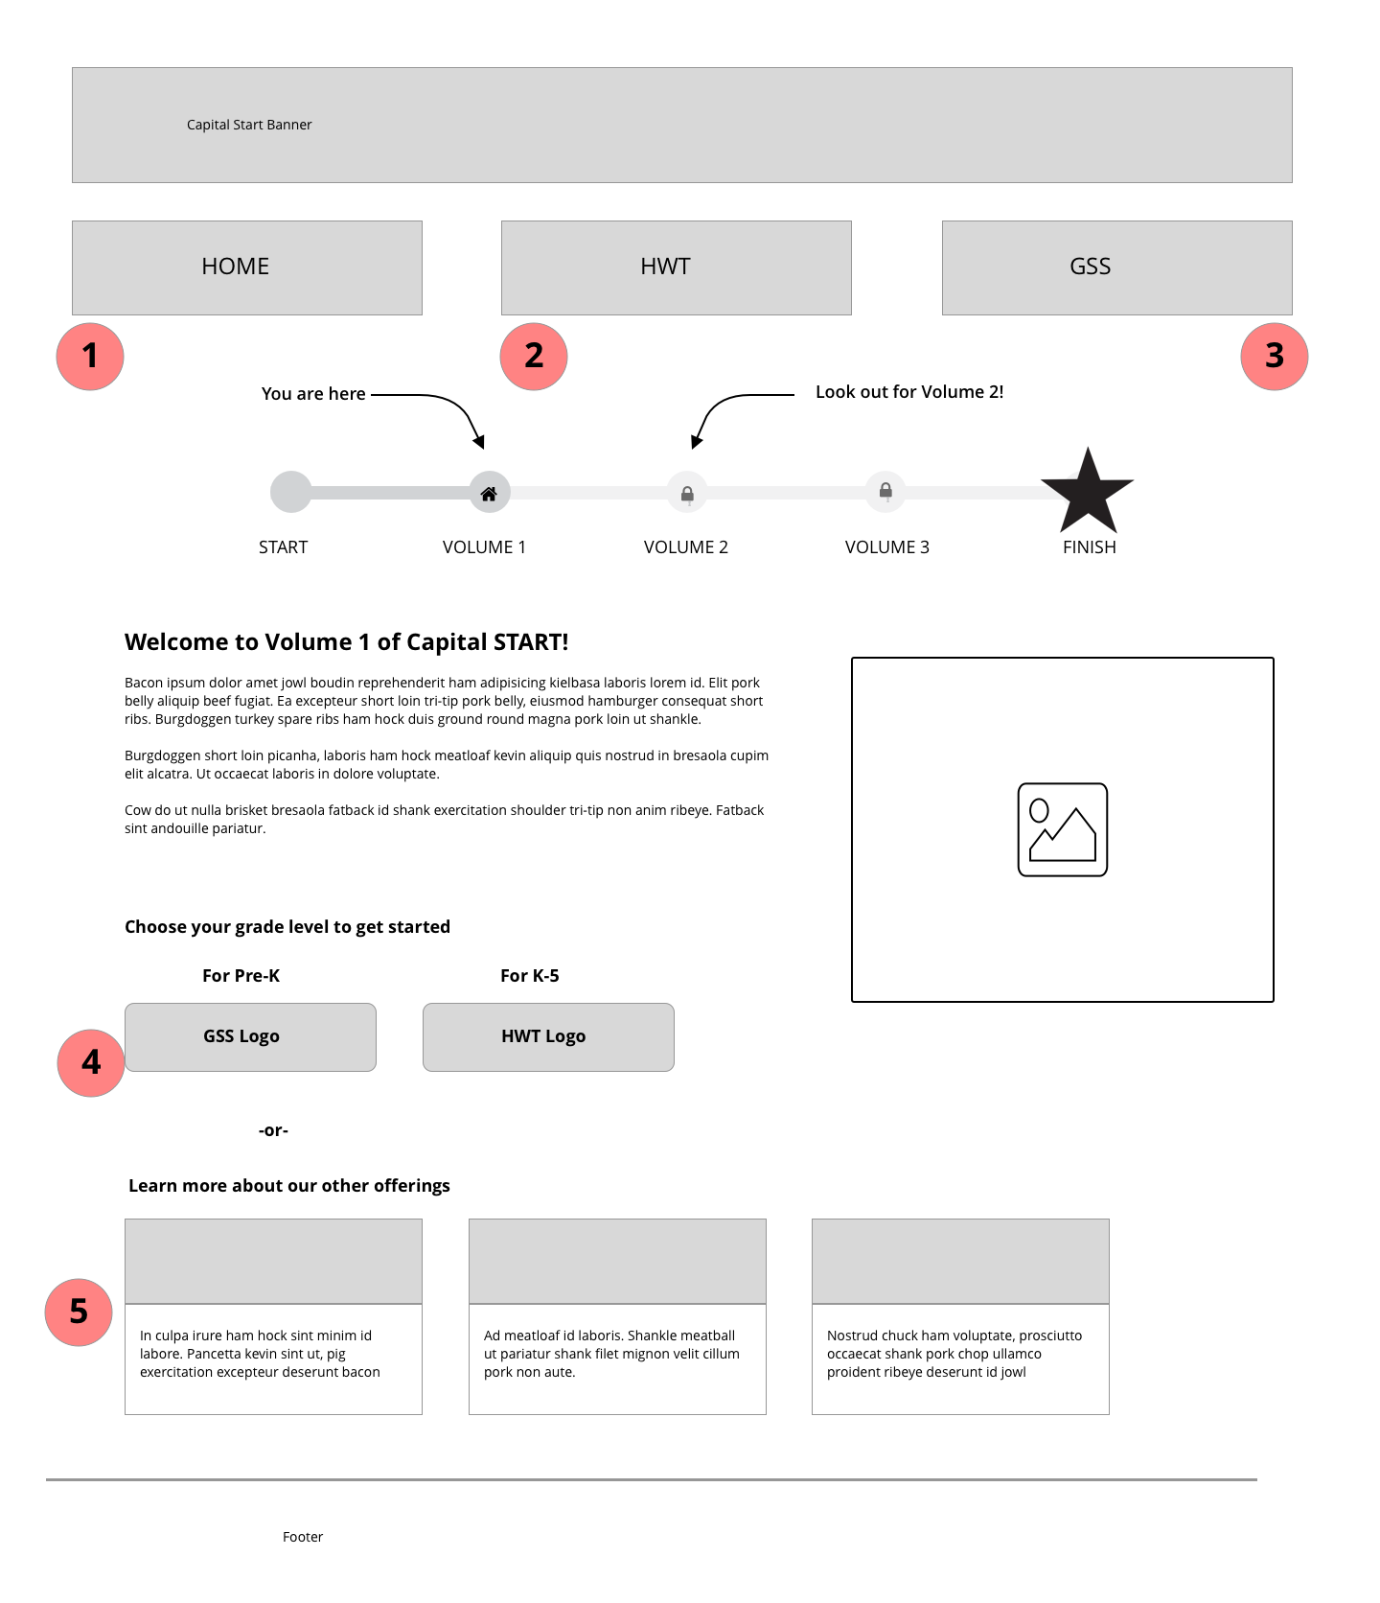

The pills at the top of the page just below the header of the landing page and program page link to

1. Volume 1 Landing page
2. HWT Volume 1 program page
3. GSS Volume 1 program page
4. HWT and GSS Volume 1 program pages, respectively
5. To the lwtears.com program page for each advertised offering

# Volume 1 capital start program pages

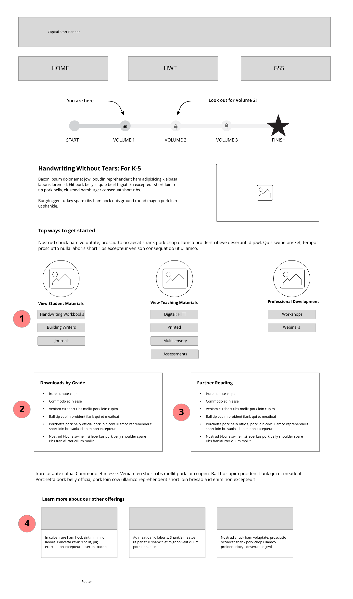

1. Each of these buttons trigger popovers upon click that can be closed either by clicking a “close” icon, or clicking outside of the box
2. This list of available downloads are linked to their respective downloadable materials.
3. The “further reading” list also has links for all linkable articles
4. To the lwtears.com program page for each advertised offering

# Volume 1 capital start program pages with open popovers

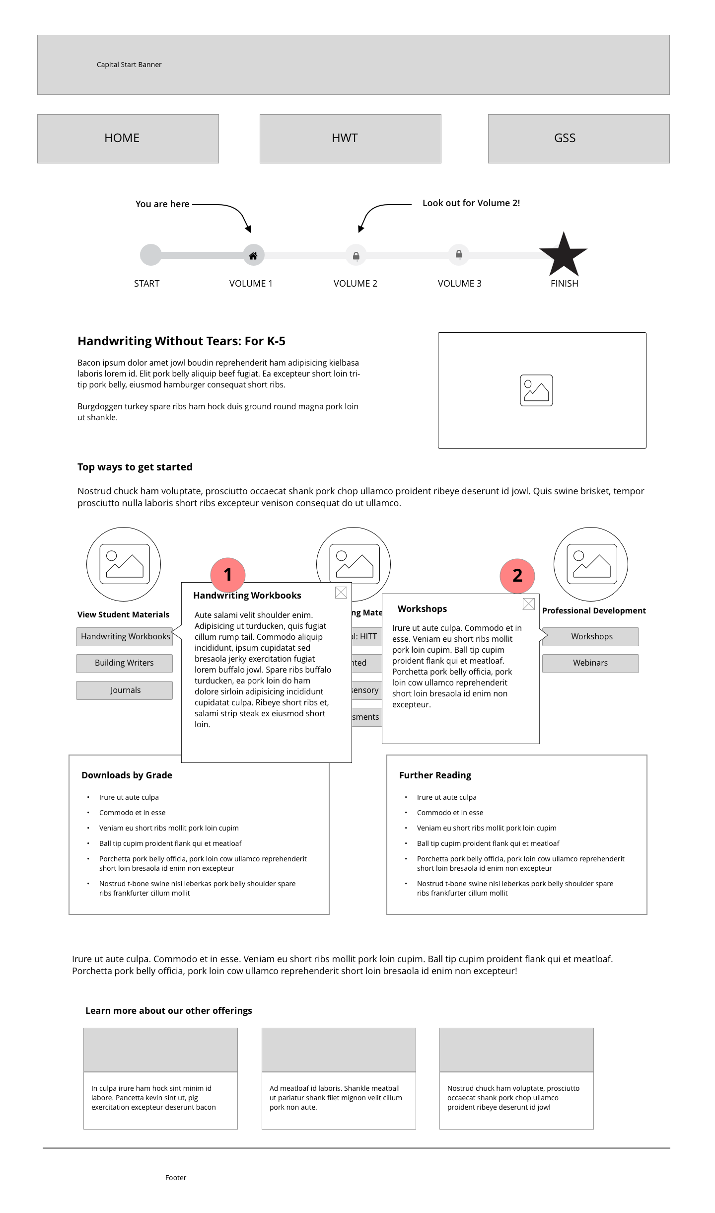

1. Each of the buttons in this section is a popover triggered when the user clicks the button and closes when the “x” is clicked or anywhere outside the box. The contents of the popovers can include text, links, and images.
2. The close icon included will close the popover. Clicking outside the box has the same effect.

Wireframes without added notation